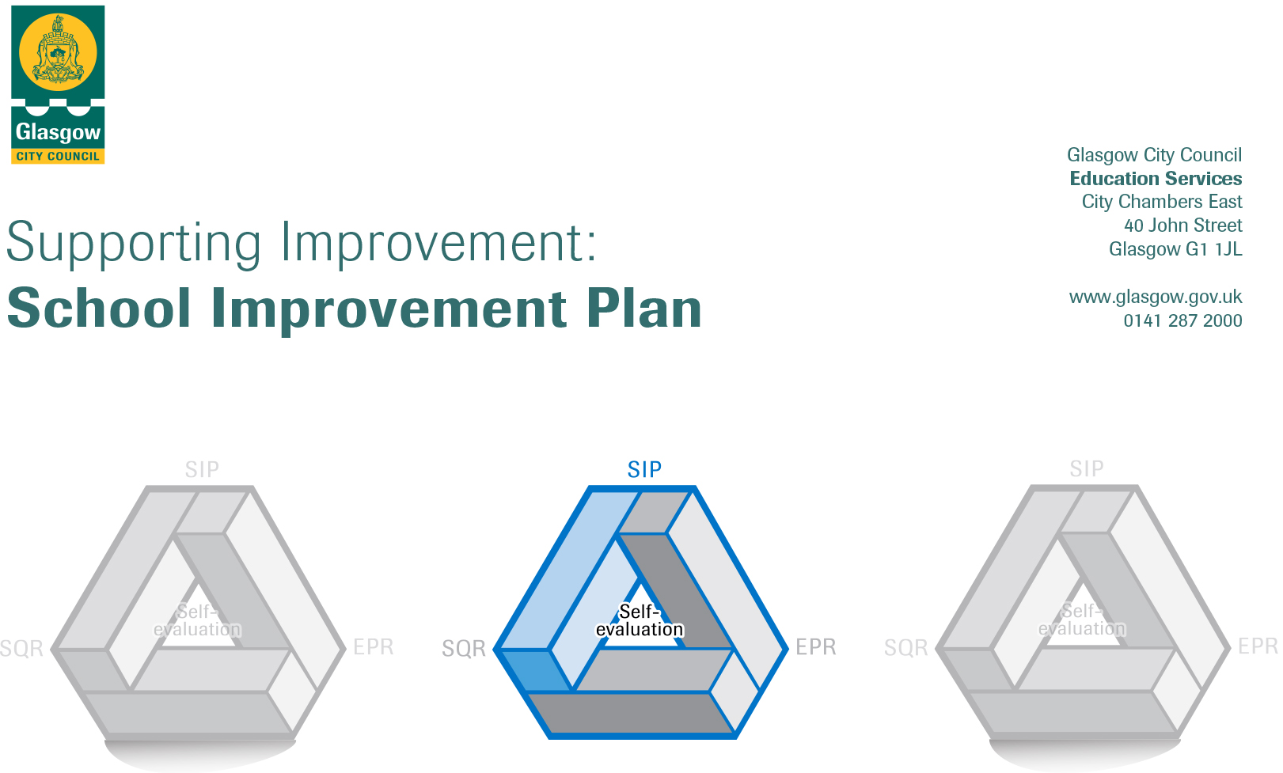

Session 2023-2024
Establishment |  | DRUMCHAPEL FAMILY LEARNING CENTRE
Head of Establishment |  | IRENE RICHARDSON
Area/Local Improvement Group |  | NW LIG1
Head of Service |  | DOUGLAS HUTCHINSON
Area ELC Manager

CONTENTS
1. Vision, Values and Aims
2. Summary of Self-Evaluation Process / Priorities for Improvement in the current session
3. Action Planning

Action Plan Summary for Stakeholders

1. Our Vision, Values and Aims
Vision
At Drumchapel Family Learning Centre we are committed to providing the high quality learning and teaching experiences in partnership with families and the wider community. We strive to empower all who are involved within the centre to reach their full potential to be the best they can be.

Values
- Children’s Rights are at the heart of all that we do.
- The nursery promotes open communication, honesty, trust and kindness.
- The views of children, parents and staff support decision-making and influence all aspects of nursery life.
- We value, respect and celebrate diversity.

Aims
We aim to ensure that Drumchapel Family Learning Centre is a place where:-
- children are nurtured, happy and feel safe
- children’s individual rights are promoted
- children are shown love and affection
- children can laugh, have fun and become excited about learning
- stimulating and suitably challenging learning environments support children’s learning, development and attainment
- inclusion is a key principal; respect for others is promoted
- achievements are celebrated
- parental involvement is encouraged
- open communication exists
- staff are professional, helpful and kind, and make families feel welcome; they take time to listen and understand others
- staff are motivated, enthusiastic and work as a team; they are passionate about facilitating active learning for children.

2. Summary of our self-evaluation process.
- Our quality assurance calendar provides clear guidelines for systematic evaluation of practice areas using a range of self-evaluation tools including ‘How Good is our Early Learning and Childcare’, ‘Realising the Ambition’, and ‘How Nurturing is our School ‘.
- Within each improvement priority set out in the establishment improvement plan, self-evaluation was an on-going process.
- Consultation with stakeholders and partners through discussions and questionnaires, including a great deal of staff discussion and reflection to evaluate the service and provision. Children’s views about the nursery was gathered in various ways such as through discussions and reflecting on nursery experiences.
- Regular Management Team meetings, playroom observations, visits from/discussions with critical friends such as other local area Heads and colleagues, and NW Area Early Years Manager.

Strengths identified:
- Staff support children well to make progress in their learning. This year attainment in Literacy & Numeracy has improved; 52% of pre-school children on track with learning in Early Level Maths & Numeracy. In Early Level Literacy, 85% on track in Listening & Talking, 70% on track with Reading, and 77% on track with Writing.
- All children receive nurturing support, children who have additional support needs receive very good responsive care and support.
- Working in partnership with parents and the quality of our family learning programme.
- The specialist skills of staff are recognised and well utilised, there is effective leadership at all levels.
Priorities for development:
1: Ensuring wellbeing, equality and inclusion - Nurturing Approaches; Children are nurtured and supported throughout their daily experience

2: Personalised Support – Meeting the needs of all children

3: Developing creativity and skills for life and learning

No. | Quality Indicator | Priority – (This should be a measurable outcome)
1 | 3.1  CS 1.1,4.1 | Ensuring wellbeing, equality & inclusion - Nurturing Approaches; Children are nurtured and supported throughout their daily  experience in nursery  - Nurturing approaches used consistently throughout the nursery promotes and maintains positive relationships. Children experience warmth, caring and nurturing approaches to support their overall wellbeing.  - All behaviour is seen as communication; staff discussions and planning around behaviour are supportive and solution focused. Staff support the individual needs of all children to help every child to achieve their potential.  - Staff practice is underpinned by the United Nations Conventions on the Rights of the Child; staff interactions with children are loving and caring and support children to understand their rights.  - The nursery’s application for EY Nurture Award is successful.

Tasks/Interventions to achieve priority | Staff leading on this priority – including partners | Timescale/  Checkpoints | Success Criteria – What do you predict will be the impact on learners?  (Data, observation, views)
Staff Discussion:  - Analysis of data (of ‘How Nurturing is our School’ staff questionnaire)  - process for the EY Nurture Award | HOC -Irene Richardson  Depute - Kathleen Diver  EY Nurture Team (Educational Psychology Service) | August inset | - Data analysis of staff questionnaires (completed May inset day) identified that staff would benefit from revisiting Nurture Principle 5 ‘All Behaviour is Communication’.  - The process for application for EY Nurture Award is clear for all staff.
Staff to complete self-evaluation exercise using EY Nurture Award ‘Features of best practice’ document. | All EY staff  EY Nurture Team | August inset  Action - ongoing.  Checkpoint – Term 2, 3, 4 | - Analysis of completed evaluation exercise will highlight areas of good practice. The data will be used to support further practice improvement, leading to better outcomes for children.
Staff refresher training – EY Online Modules ‘An Introduction to Five to Thrive’ (Modules 1 and 2) | Lead - Depute Kathleen Diver  All EY Staff | Term 1 | - Post training feedback show staff have good awareness of the Five to Thrive Programme. Staff have a good understanding of how connected relationships are crucial for a child’s wellbeing and for healthy brain development, and how this impacts on future development and learning.  - Playroom monitoring shows that the five key activities are embedded in daily practices and as a result our children are thriving.
Staff refresher training  Nurture Principle 5 ‘All Behaviour is Communication’ | Graeme McLeary (Educational Psychologist)  All EY Staff | August inset | - All behaviour is Communication is embedded in daily practice and staff display confidence using support strategies to help children regulate their emotions.  - Pre and post training questionnaires are positive and provide evidence of professional learning.
Children’s Rights:  - revisit UNCRC  - evaluate Rights-based approaches in nursery to identify areas for improvement | LEL Team  Team Leader - Sian Connelly  LPA - Lisa  All EY staff  Children & families | October inset | - Staff engage with UNCRC article. In their practice they demonstrate an understanding of how children’s rights translate from policy into meaningful, everyday experiences for young children in a nursery setting.  - A rights-based approach in nursery helps children to develop an awareness of their rights; they can talk about their rights to others.
Annual Child protection and safeguarding training for all staff | HOC -Irene Richardson  (Child Protection  Co-ordinator)  All staff | August inset | - All staff have a clear understanding of  - their roles and responsibilities relating to keeping children safe and protected.  - Legislation in relation to safeguarding & child protection and of the practice and procedures within the establishment.
Annual review of nursery Vision, Values, & Aims | Head of Centre  All EY Staff  Parents  Children  Partners in the community | Consultation August – to be finalised by end September 23 | - An agreed VVA created by the whole nursery community ensures that everyone is working towards the same goals which is reflected in establishment policies and procedures and in our daily practices.  - The nurturing principles are communicated as a key aspect of the shared nursery philosophy.
Ongoing monitoring and evaluation of practice.  Submit application for EY Nurture Award | HOC Irene Richardson  All EY Staff  Graeme McLeary (Educational Psychologist)  EY Nurture Team | Term 4  Termly checkpoints | - The nursery’s application for EY Nurture Award is successful.

Looking Forwards - Next Steps
(Not to be completed until priority achieved)

No. | Quality Indicator | Priority – (This should be a measurable outcome)
2. | 2.4  3.1  CS 1.1, 4.3 | Personalised Support – Meeting the needs of all children  - All children receive high quality support. Universal and targeted support has a positive impact on children’s progression and development; all children are achieving,  - Inclusive practices are embedded across the centre. Staff interactions with children who have additional support needs are sensitive and responsive and help children access a full range of experiences.

Tasks/Interventions to achieve priority | Staff leading on this priority – including partners | Timescale/  Checkpoints | Success Criteria – What do you predict will be the impact on learners?  (Data, observation, views)
Are we getting it right for every child?  - Continuous review and evaluation of learning environments, making adaptations as required, to ensure environments are enabling and safe and meet the needs of all children, in particular for children who have additional support needs.  - Continuous review and evaluation of provision including structure and pace of the day, the quality of interactions and support strategies for children with additional support needs.  *Use of self-evaluation tools including  HGIOELC, CI Quality Framework, Realising the Ambition, Self Evaluation Instrument for Care Setting (Ferre Laevers) http://www.kindengezin.be/img/sics-ziko-manual.pdf  Learning with Autism www.ASDinfoWales.co.uk/early-years.  Sensory Audit for Schools & Classrooms https://education.gov.scot/media/i3nm5bkt/sensory-audit-tool-for-environments.pdf | SMT  All EY Staff.  Cat McLennan (EY Inclusion Outreach Service) | Ongoing throughout the year.  Regular checkpoints | - Ongoing monitoring and self-evaluation processes show there is an optimum learning environment i.e. one that is enabling, safe, and meets the needs of all children.  - Observations show that children are relaxed and feel safe  - .Data gathered shows there is less evidence of children displaying distressed, anxious, challenging behaviour.  - Reflection and on-going monitoring carried out by SMT and staff show that routines in place and pace of the day offer a positive experience for all children.  - Tasks, resources and experiences are relevant and purposeful and are at the right level to help children make sustained progress.  - Observations, trackers, children’s learning journals show targeted interventions are effective and lead to positive outcomes for children.
Collaborative working with EY Inclusion Team (outreach service) to effectively support children who have additional support needs. | Cat McLennan (EY Inclusion Outreach Service)  SMT& All EY Staff. | Term 1 | - Practitioners reflect on their own practice. Through engaging with specialist support they increase their ability to meet the diverse development and learning needs of each child.
Introduce Milestone trackers to track the progress of children who have additional support needs. | HOC – I.Richardson  Graeme McLeary (EP) | Introduce Term 1  Checkpoint -Termly | - Trackers are used effectively to help identify children’s progression of learning and support the planning process for improved outcomes for children.
Self-evaluation exercise using CI Practice note ‘Supporting positive mealtime experiences.  Engage with/ seek advice from:  - EY colleagues across the city who have established a more child-centred approach to mealtimes within their establishments.  - Catering & Facilities Management Team  Introduce changes to lunchtime provision as identified through self-evaluation processes to provide a positive experience for all children.  Continuous Review/ evaluation of mealtimes in nursery. | Management Team  All EY Staff  Emily-Jane Russell (CFM)  EY Colleagues  Parents & children | Introduce Term 1  Checkpoint - Termly | - Through the process of looking inwards, looking outwards, and looking forward changes made to the lunchtime routines in nursery has a positive impact for all children.  - Lunchtime is a pleasant, sociable experience for all children. Children and staff enjoy eating together in an unhurried and relaxed atmosphere.
Looking Forwards - Next Steps
(Not to be completed until priority achieved)

No. | Quality Indicator | Priority – (This should be a measurable outcome)
3 | 3.3  CS1.3 | Developing creativity and skills for life and learning  - All staff understand the value of open ended approaches to teaching and learning to support children’s creativity and attainment; they demonstrate this in their daily practice and interactions with children.  - All staff understand how digital technology can be used to encourage creativity, enhance learning, and raise attainment  - Observations and assessment data show the majority of children are developing creative thinking skills.

Tasks/Interventions to achieve priority | Staff leading on this priority – including partners | Timescale/  Checkpoints | Success Criteria – What do you predict will be the impact on learners?  (Data, observation, views)
Staff Exercise – What is Creativity?  Complete Audit of provision and practice  Action gaps in provision. | HOC Irene Richardson  All EY Staff | Term 1  Ongoing throughout year | - Audit completed successfully – Gaps in provision identified and actioned resulting in improved opportunities and outcomes for children.
Staff Training – signpost to online modules & podcasts for early years professionals by Starcatchershttps://starcatchers.org.uk/development_type/early-years-professionals/  Staff Training:  - Creativity for Inclusion & Inclusion for Creativity - session 1 Visual Arts  - Creativity for Inclusion & Inclusion for Creativity - session 2 Music | All EY Staff  Starcatchers materials  Jane Catlin Strathclyde University  Paul Wickham  Strathclyde University | Term 1  Feb inset day  Twilight  27th Feb 24 | - Feedback from staff is positive; all staff have an increased awareness of how to support children’s creativity.  - Through engaging in training staff have gained fresh inspiration and learned new approaches to encourage creativity across the curriculum. As a result experiences offered are more exciting and motivating for children.
Ongoing monitoring and evaluation | Management Team  All EY staff | Termly Checkpoints | - Playroom monitoring shows:  - the learning environment and structure of the day encourages creativity.  - children have access to open-ended play materials to extend their creativity and thinking  - Staff use innovative approaches and offer high quality experiences that enable children to explore ideas and materials and to use their imagination freely.
Digital skills  Follow-up training/support sessions for staff in effective use of i-pads to enhance teaching and learning. In particular, looking at ways to use apps to encourage creativity, imagination, and problem solving, and enquiry. | Nursery DLOL – Kathleen Diver  Stuart Cheyne (XMA)  All EY Staff | Jul/Aug / Sept  Various dates | - Staff have increased confidence in the use digital enhancements to support children’s learning.  - The majority of children use digital technologies confidently and demonstrate improved creative thinking skills.
Use seesaw effectively as part of nursery/home links to involve parents in their child’s learning.  Support children and parents to gain the skills and confidence to embrace and use technologies at home to enhance learning. | Nursery DLOL – Kathleen Diver  Stuart Cheyne (XMA)  All EY Staff | Beginning in Term 1  On-going monitoring  Checkpoints:  Dec 2023  May 2024 | - The majority of staff are familiar with how to use seesaw. Over time they have developed confidence to use Seesaw to highlight and share with parents children’s learning of key skills, and to post learning experiences that can be carried out at home.  - Parents feel better informed about their child’s progress. increased parental involvement in their child’s learning journey.

Looking Forwards - Next Steps
(Not to be completed until priority achieved)

